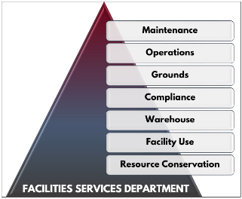
Facilities Services Department
17810 8th Ave So, Bldg C
Burien, WA 98148
206.631.7501

PAINT PROJECT CRITERIA and REQUIREMENTS
There are additional procedures for those proposing paint projects within the district. First, the project will be scheduled on availability on the paint project calendar. There is a limited number of paint projects Facilities will allow district-wide, at one time. Please consult with the Self-Help Project Coordinator at 206.631.7501 for calendar availability.

Please keep in mind that we do not accept new self-help projects between June 15th and September 15th, each year, due to the heavy workload of our Maintenance and Grounds leads during this time.

Second, paint projects have a 3-Step approval process. Project participants must have one phase completed and be signed off before moving on to the next phase. (Example: Wall color paint will not be delivered until prep has been completed and signed off by Facilities. In addition, a Self-Help Paint Kit and agreement must be signed and checked out, from Facilities.)

The district recommendation for classroom paint projects is any shade of white. All paint colors are subject to approval, and a CHANGE of color (Example: Painting a white room a deep purple or a hallway mustard yellow) will need a rationale for change. Please be advised Facilities may supply up to 10 gallons of paint.
The Paint Shop Lead will be assigned to oversee the project. He will meet with you personally to go over the specs of your project and review the proper procedures for painting, prep, and clean up. If it is a mural or art-based project, a rough draft drawing must be submitted with the application.

Once you have completed the necessary paperwork (application, roster and paint kit agreement), and it has been approved, the paint project may then be completed, as follows:

Phase 1: Prep
- Check out Self Help Paint Project Tool Kit, from Facilities. Only those items in the kit, will be provided by Facilities; any items not in kit, must be purchased by project participants.
- Furniture & wall décor removed
- Wall Prep/Cleaning (including removing nails, repairing holes)
- Tape & Plastic Room and windows
- Contact Paint Lead to schedule meeting to verify completed

Phase 2: Prime & Paint
- Primer on Walls
- Color on Walls
- Trim- if applicable
- Contact Paint Lead to schedule meeting to verify completed

Phase 3: Clean Up
- Rollers and brushes washed
- Trays cleaned out
- Plastic & tape removed
- Self-Help Paint Tool Kit returned to Facilities Department
- Contact Paint Lead to schedule meeting to verify completed

At this time the Paint Lead will sign off on your completed project.

For additional questions regarding how to complete any paint project, please call 206.631.7501, and ask for the Self-Help Coordinator.

Thank you for your interest!

